Canada Day Coffee Ride
Sunday June 29/14

Who? You!! Any rider from an ABA affiliated club is welcome.
If you are on the ABA member list you are good to go!
Where? Meet at Tim Horton’s in Devon
When? Sunday June 29 at 9:30 am – ride at 10am.
Get there early for coffee and breakfast specials.
What? A group ride with three distances: 80, 110 and 145 km with coffee stops.
No support but we will give you a map. We will split into groups based on ability and distance.
Why? Cause you like to ride your bike. Duh.
Routes:
85 km
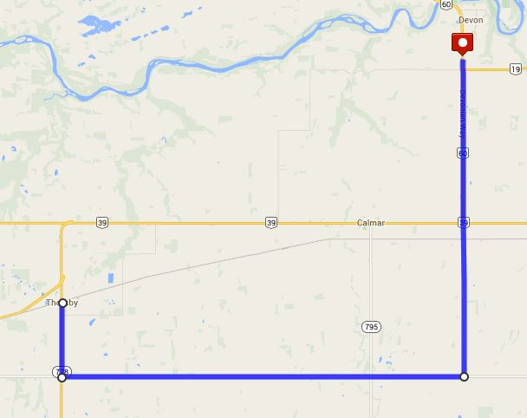
- Ride south from Devon on Hwy 60
- Cross Hwy 39 and continue south on Range Road 263
- Turn right onto Township 490
- Ride west to Hwy 778
- Turn north to Thorsby – coffee/food stop
- Turn around and ride home!

110 km
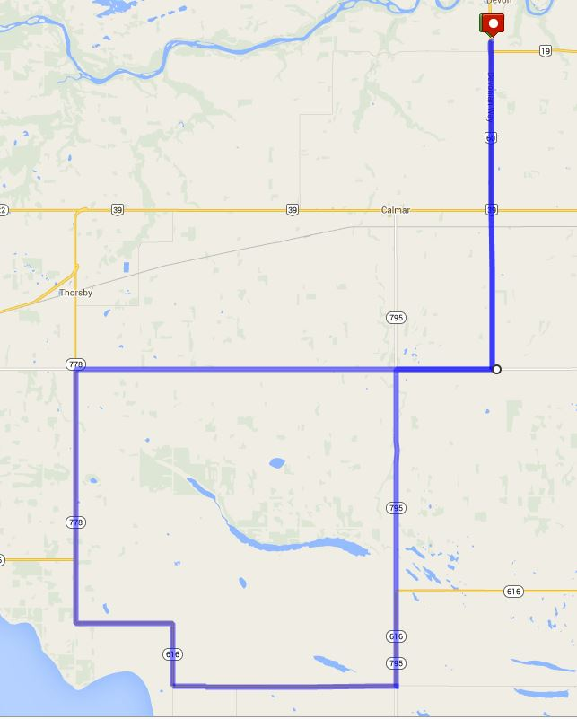

- Ride south from Devon on Hwy 60
- Cross Hwy 39 and continue south
- Turn right onto Township 490
- Ride west to Hwy 778
- Turn north to Thorsby – coffee/food stop (if you want food or whatever) otherwise turn left and ride south on Hwy 778
- Turn left on 616 – ride east – follow 616 as it turns south then east again. Possible stop in Mulhurst – follow signs
- Turn left onto 795
- Turn right onto Township Road 490
- Turn left onto and head home.
145 km
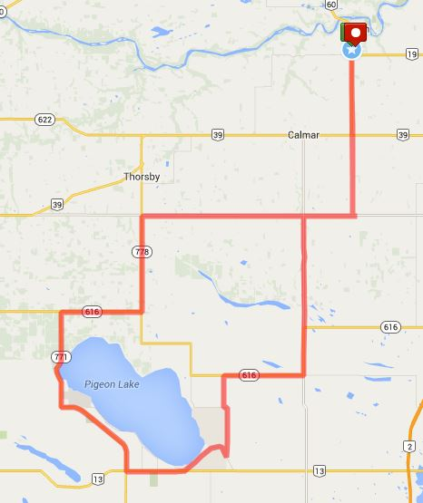
- Ride south from Devon on Hwy 60
- Cross Hwy 39 and continue south
- Turn right onto Township 490
- Ride west to Hwy 778
- Turn north to Thorsby – coffee/food stop (if you want food or whatever) otherwise turn left and ride south on Hwy 778
- Turn right on 616 – ride west
- Turn left onto 771
- Turn right Hwy 13 – coffee stop at Village on the Lake ( Eco Café has good espresso, IGA and Esso have food ) – 85 km out and 60 km to go – fuel up.
- Continue east on 13, then turn left on 13X to Mameo Beach
- Turn sharp left onto Hwy 780 and head north – make a little jog to the west then back north
- Turn right onto 616 – head east
- Turn left onto 795
- Turn right onto Township Road 490
- Turn left onto Range Road 263 and head home.

