# **Juventus CC Junior Spring Break Road Camp**

## Penticton BC, March 29th to April 5th, 2014

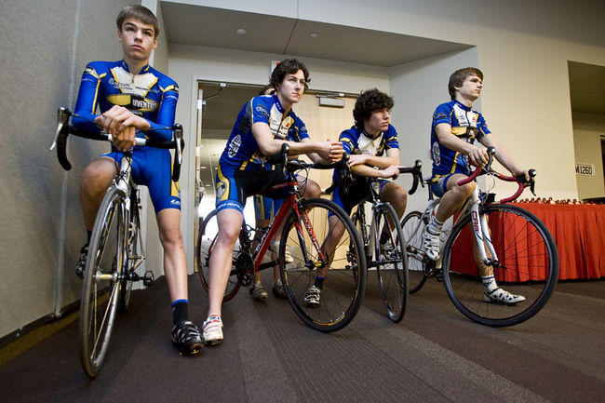

Come and spend your Spring Break in the SUNNY OKANAGAN

**Where:** **Penticton!!**

**Accommodations**: Hostelling International Penticton.

http://www.hihostels.ca/westerncanada/175/HI-Penticton.hostel

Participants are expected to help with Meal Prep and Clean-up. The cost of the camp covers Camp Coaching, transportation and 7 night’s accommodations. Breakfasts and Dinners are also included

Cost **$520.00** to be paid by March 12th

A trip meeting will be held Wednesday March 19th. At this time we will be discussing transportation, rooming, packing lists, work sharing, meal assignments and ….

All participants must have their 2014 Juventus Membership and 2014 ABA racing License. This is an insurance issue so there will be no exceptions.

For more information contact:

Tracy Shearer @ 780-418-4306 or Ken Germaine @ 780-433-9907 (home), 780-232-3962 (cell) or [5germs@gmail.com](mailto:5germs@gmail.com)

Coaches will be Tracy Shearer and Ken Germaine, NCCP Certified cycling coaches

